CENWP-OD-D 9/30/2022

MEMORANDUM FOR THE RECORD

SUBJECT: 22TDA13 MFR Spearfish Boat Ramp Salmonid Mortalities

On 9/23/22 a person from the Washington Dept. of Fish and Wildlife (WDFW) informed The Dalles Dam resource staff of several dead fish dumped at the boat ramp at Spearfish Park into Spearfish Lake. The WDFW employee learned of the incident from a member of the public. The Dalles Dam ranger staff confirmed 40-50 decomposing salmonid carcasses. An officer from WDFW also surveyed the scene.

- Species –Appear to be mostly chinook, however, species identification is hampered by decomposition.
- Origin – NA
- Length – NA
- Marks and tags – NA
- Marks and Injuries found on carcass – NA
- Cause and Time of Death – NA
- Future and Preventative Measures – Catch the people who dumped them.

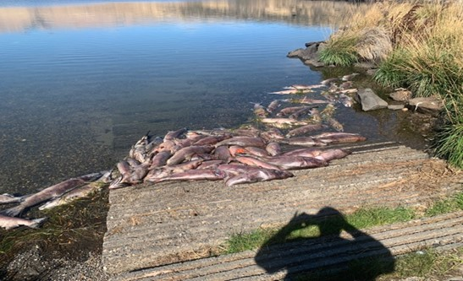

Fig 1. Decomposing salmonid carcasses found at the Spearfish Boat ramp on 23 September 2022.

Sincerely,
The Dalles Project Fisheries

